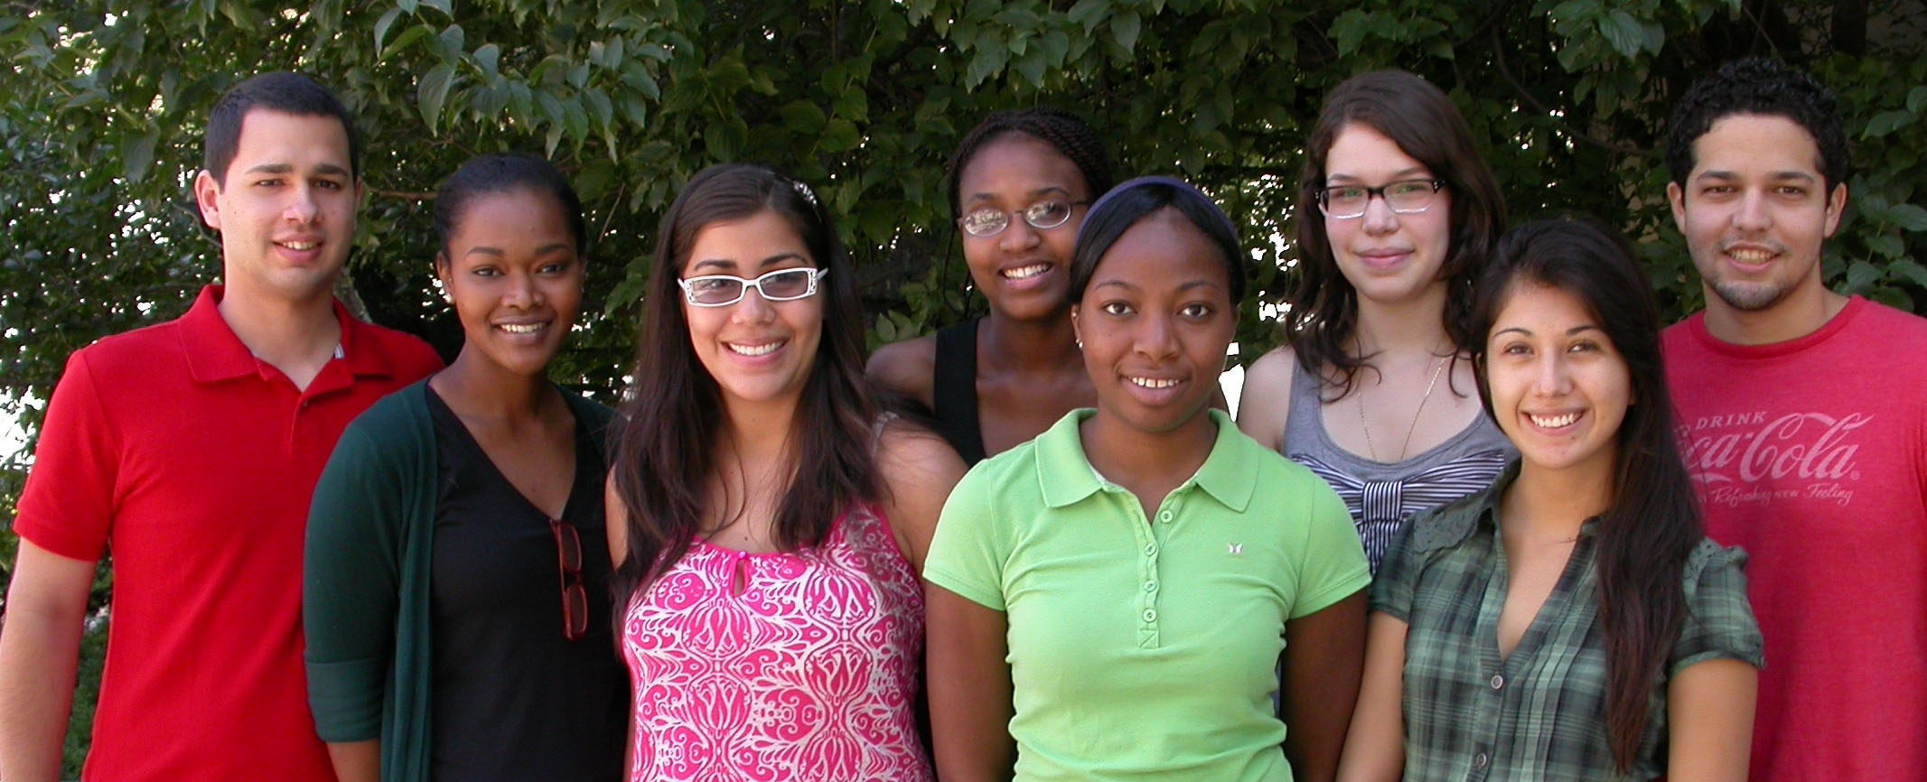

THE PREP (Post-Baccalaureate Research Education Program) is a unique opportunity for groups underrepresented in the biomedical or behavioral sciences who hold a recent bachelor’s degree in science to conduct research as lab technicians for one year at the University of Chicago. Participants in the PREP must intend to pursue a PhD degree upon completion of this Program. In addition to employment, PREP Scholars participate in academic activities designed to help them prepare for successful application to a PhD program.

APPLICATION TO THE PREP is a competitive process. Selection is based on an application form, transcripts, letters of reference, past research experience, research interests and career plans. Applicants must be U.S. citizens or permanent residents. Although formal applications may be submitted at any time during the year, Scholars begin in the summer.

THE PREP SCHOLARS PROGRAM is designed to offer specific academic, cultural and social activities. Some of these activities will be completed in one academic quarter (10-12 weeks) and others will continue throughout the academic year.

EARLY ACTIVITIES include orientation, lab rotations to choose a mentor (if necessary), self-assessments, and a series of GRE workshops.

FALL QUARTER includes lab research, travel to a national conference, and the weekly Journal Club, which continues throughout the year and ends with the PREP Symposium in the spring.

WINTER AND SPRING QUARTERS include a writing course and an ethics course, respectively. Scholars may also take an academic course each quarter. Throughout the year Scholars attend lunches, meetings, workshops and cultural events with other PREP Scholars, and are encouraged to attend seminars, data meetings and a scientific conference with their lab group.

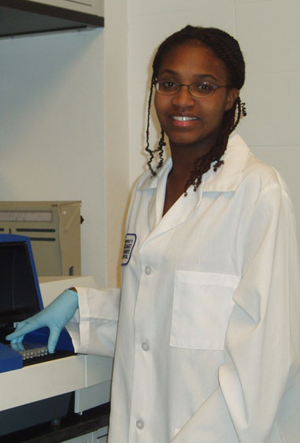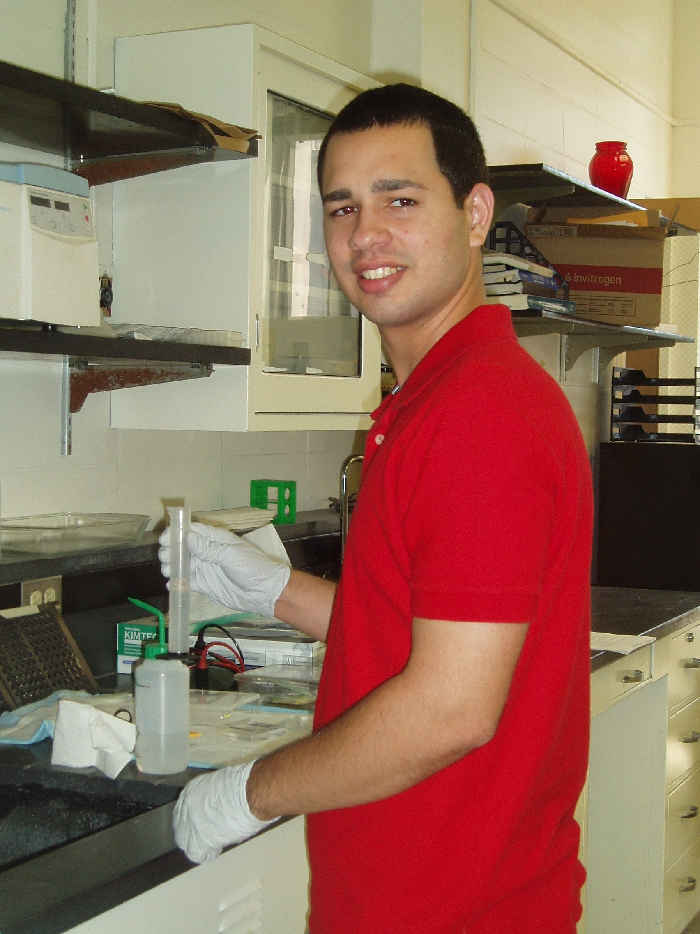
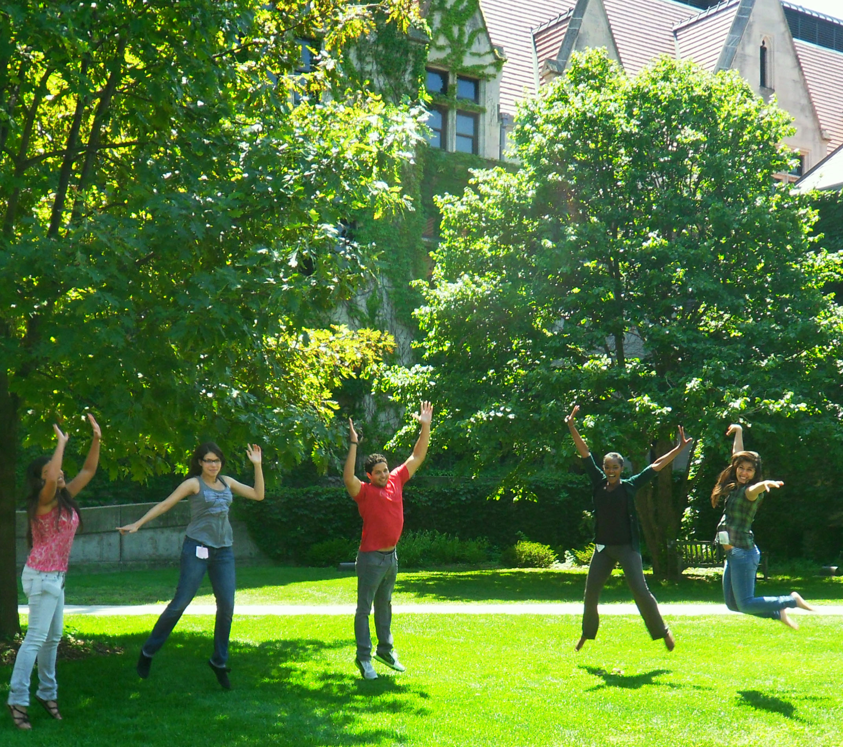

ALL PREP SCHOLARS receive a salary of $27,000/year for their work as lab technicians, as well as employee benefits such as health insurance, free computer courses, and personal and professional counseling.

MENTORS from a wide variety of research fields participate in this Program. While the research projects are frequently basic in nature, Scholars are encouraged to pursue research in areas that address reducing health disparities, such as respiratory diseases, cancer, arthritis, cardiovascular disease, diabetes, substance abuse and infectious diseases.

THE UNIVERSITY OF CHICAGO is located seven miles south of the city center in the community of Hyde Park/Kenwood. The campus is bordered by two major parks and Lake Michigan. The University of Chicago campus consists of stately gothic buildings furnished with the latest scientific facilities.

THE CITY OF CHICAGO offers endless activities for entertainment and leisure -- restaurants, sporting events, cultural events, & shopping for all tastes and budgets. Many students, staff and faculty live in the neighborhood of Hyde Park where the University of Chicago is located, and walk to campus.

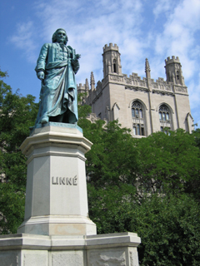
SPECIFIC INQUIRIES about the Post-Baccalaureate Research Education Program (PREP) should be addressed to:

Dr. Nancy B. Schwartz
Director, PREP
Department of Pediatrics
5841 Maryland Avenue, MC 5058
Chicago, IL 60637
prep@lists.uchicago.edu

Find more information on our website:
http://bsdprep.uchicago.edu

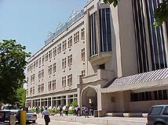

In keeping with its long-standing tradition and policies, the University of Chicago, in admissions, employment, and access to programs, considers students and employees on the basis of individual merit without regard to race, color, religion, sex, sexual orientation, age, national or ethnic origin, handicap, or other factors irrelevant to work or study in the programs of the University.
THE UNIVERSITY OF CHICAGO

DIVISION OF BIOLOGICAL SCIENCES
PRITZKER SCHOOL OF MEDICINE

PREP
Post-Baccalaureate
Research
Education Program

Supported by

The National Institute of General

Medical Sciences

