**THE UNIVERSITY OF CHICAGO**



**Division of Biological Sciences**

**Pritzker School of Medicine**

**PREP**

**Post- Baccalaureate Research Education Program**

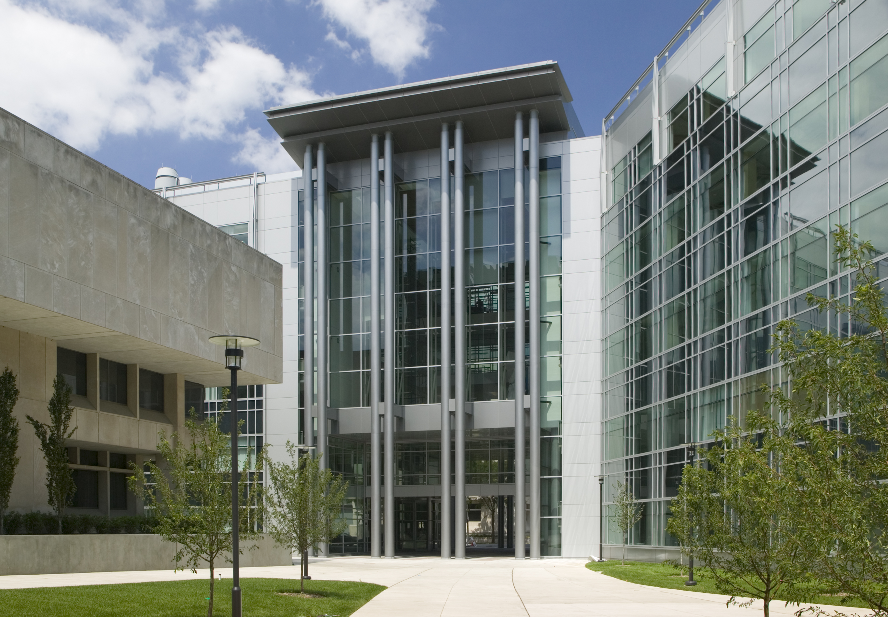

The PREP is an opportunity for those underrepresented in science who

hold a recent bachelor's degree and wish to engage in extensive research and other skill-building activities for one year at the University of Chicago.

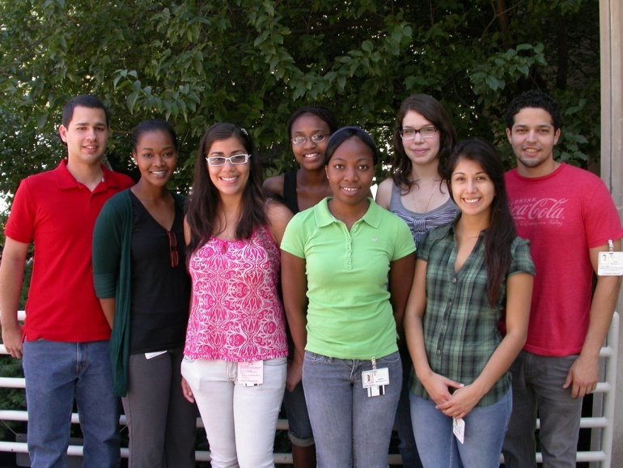

Participants in the PREP must

intend to pursue a PhD upon completion of their participation in this Program. In addition to lab-based research, PREP Scholars participate in academic activities designed to help them prepare for successful application to an advanced degree program.

For more information contact:

Dr. Nancy B. Schwartz, Program Director

[prep@lists.uchicago.edu](mailto:n-schwartz@uchicago.edu)

Application forms are available at:

http://bsdprep.uchicago.edu