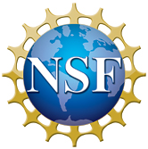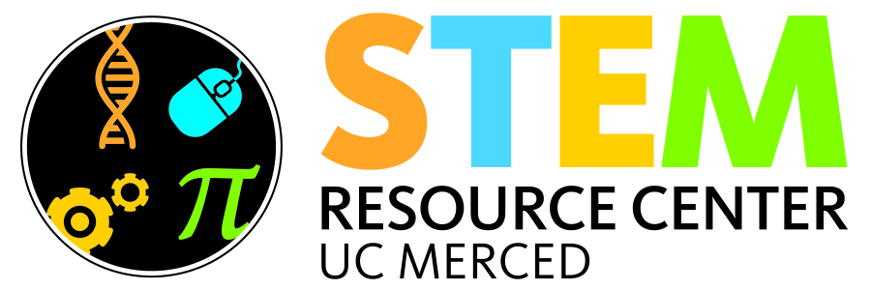 Home http://nano.illinois.edu/summer-institute-2014/Publish/images/imark.jpg

**NanoBIO Summer Research Program**

**July 14 – August 8, 2014**

Deadline for Application Materials:

April 30, 2014

**Program details**

* Duration: 4 weeks (July 14 – July 25 UC Merced; July 18 – August 8 University of Illinois at Urbana-Champaign, UIUC)
* Benefits:
  + $ 13/hr stipend
  + Covered travel and accommodations at UIUC
  + Paid two weeks research-related experiences, one-on-one faculty mentoring, and NanoHUB training at UC Merced
  + Paid two weeks of lectures and hands-on training at the UIUC
* **Application Deadline: April 30, 2014**

**Research experiences**

* At UC Merced:
  + Hands-on research lab activities within School of Natural Sciences and School of Engineering
  + Faculty mentoring and experimental learning
  + NanoHUB workshop – training on the NanoHUB and the use of Rappture toolkit to create graphical user interfaces (GUI) for simulation tools
  + Present a poster upon completing the program
* At UIUC:
  + Hands-on training on topics such as cancer nanotechnology, cell mechanics, molecular biology, micro fabrication, and NanoBio devices
  + Lectures presented by experts in the engineering and physical sciences fields

**Eligibility:**

* UC Merced enrolled full-time undergraduate student
* At least 4 semesters of college experience
* 3.0 cumulative GPA or higher
* US Citizenship or Permanent Resident Status

**Application Information:**

* Application Package:
  + Complete Application Form (found at <http://stemresourcecenter.ucmerced.edu>)
  + Unofficial Transcript
  + Resume
  + A brief description of research you would like to do while in the program (limit 1 page). Include the name of the faculty member you prefer to work with, or you are already working with.
  + One letter of recommendation from a UC Merced faculty member
* Application Submission Process:
  + E-mail pdf files of Application Form, Transcript, Resume, and Personal Statement to Petia Gueorguieva, [pgueorguieva@ucmerced.edu](mailto:pgueorguieva@ucmerced.edu). Use subject line “Your Name – NanoBIO Application Submission”.
  + Arrange for your Letter of Recommendation to be submitted to Petia Gueorguieva at [pgueorguieva@ucmerced.edu](mailto:pgueorguieva@ucmerced.edu).

**Contact Info:**

Petia Gueorguieva, PhD

STEM Resource Center Coordinator, UC Merced,

[pgueorguieva@ucmerced.edu](mailto:pgueorguieva@ucmerced.edu),

AOA 130, (209) 228-3037